
Project Title _____________________

Submitted in partial fulfillment of the requirements for the award of the degree of
Bachelor of Computer Application (BCA) / Master of Computer Application (MCA)/ Master of Science (Data Science) MSc (DS)
By
Student Name: ____________________
Enrollment No: ____________________
Under the guidance of
Guide/Mentor Name: ____________________

Certificate
Copy to the certificate received from Qollabb to be pasted here.

Declaration
I, ____________________, hereby solemnly declare that the project report titled "____________________" submitted in partial fulfillment of the requirements for the award of the degree of Bachelor of Computer Application (BCA) / Master of Computer Application (MCA)/ Master of Science (Data Science) MSc (DS) is my original work.
I further declare that:
- This project has been carried out by me during the academic year __________ under the supervision of ____________________ (Guide/Mentor Name).
- The work has not been submitted previously to any other university, institution, or examination body for the award of any degree, diploma, or certification.
- All sources of information used in this report have been duly acknowledged and referenced in accordance with academic ethics and plagiarism norms.
- The data presented in this report is authentic to the best of my knowledge and has not been fabricated or manipulated.
- I understand that if any part of this declaration is found to be false, my project may be rejected and disciplinary action may be taken as per institutional rules.
Place: ____________________
Date: ____________________
Student Signature: ____________________
Student Name: ____________________
Enrollment No: ____________________

Acknowledgement
Write a short paragraph thanking your guide(Mentor), faculty members and organization, for their support.

Abstract / Executive Summary (150–250 words)
- Topic of the study
- Objective
- System Analysis
- System Design
- System Implementation
- Testing
- Future Scope

Table of Contents
Table of Contents
Certificate 1
Declaration 2
Acknowledgement 3
Abstract / Executive Summary (150–250 words) 4
Table of Contents 5
Abstract 6
Chapter 1: Introduction 7
Chapter 2: System Study 11
Chapter 3: System Analysis 14
Chapter 4: System Design 18
Chapter 5: System Implementation 23
Chapter 6: Testing 26
Chapter 7: Results & Discussion 31
Chapter 8: Conclusion & Future Scope 33
Chapter 9: References 35
Chapter 10: Appendices 37

Abstract
This research explores customer purchasing behavior through exploratory data analysis and visualization approaches using a publicly available dataset on shopping trends with 3,900 individual customer records. The central aim of the project is to explore correlations between demographic factors, product types, geographical locations, payment preferences, and purchase habits on the one hand and consumer behavior on the other hand. This study adheres to a well-defined process, which includes data acquisition, preparation, exploratory analysis, visualization, and interpretation of findings for the benefit of business decision-makers. The chosen dataset is structurally neat in the sense that there are no null entries and duplicates in it. Hence, this project can focus more on its analytical dimension than any data pre-processing activities. New fields such as number of purchases annually, estimated time period between purchases, annual expenditure estimate, and an approximation of the customer lifetime value during three years have been created in the dataset to bring about a business-oriented perspective. In addition to this, the analysis reveals that clothing occupies the highest market share, that autumn purchases involve the highest mean transaction volume, and that frequent shoppers still carry great significance despite small individual basket sizes. Besides this, a rule-based segmentation method has been employed to distinguish premium loyalists, big purchase occasional shoppers, regular budget purchasers, and low engagement clients.

Chapter 1: Introduction
However, in both traditional retail and online e-commerce, customers do not purchase randomly. There is always a certain influence of preference, seasonal demand, affordability, ease of transactions, purchasing experience, and payment methods on each order placed by a particular client. In such circumstances, companies rely on customer data extensively to analyze purchase history, seasonality, and customer loyalty. Therefore, even the simplest exploratory analysis can provide valuable insights for campaign design, goods allocation, packaging, and retention practices.

The current project is dedicated to the exploration and visualization of customer purchase behavior by utilizing exploratory data analytics (EDA). In order not to start the study by constructing predictive machine learning models, it was decided to conduct the comprehensive descriptive study first. This choice suits an academic report as EDA provides us with the understanding of the structure and quality of a dataset, allows us to detect useful patterns, and create business logic.
The chosen dataset is public shopping trends with 3,900 observations at customer level. In the dataset, there are demographic attributes like age and gender, shopping attributes including items purchased, their category, season, payment methods and location, and behavior attributes like number of purchases, previous transactions, and subscription status. All those features provide us with the ability to use the dataset for a college project in terms of descriptive statistics, customer segmentation, feature engineering, visualization, and recommendations.
Problem Statement
Many retail firms gather large amounts of customer and sales data. Nevertheless, just because of collecting data, the company will not get any valuable information. As long as buying patterns remain unclear, the firm will keep conducting the same generic campaigns, stock irrelevant products, or fail to address the needs of potential valuable customers. The issue tackled by the project is how to transform customer shopping dataset into valuable evidence of product demand, seasonality, customer segments, and purchase behavior.
Objectives of the Study
Objective | Output
Data collection | Gather a relevant open retail/e-commerce dataset
Data cleaning and profiling | Check for missing, duplicate and consistent entries
Descriptive exploratory data analysis | Mean, median, counts and distributions
Customer behaviour study profile | Customer demographics items, mode, payment location and seasonality
Feature engineering | Create purchase frequency, total year pending CLV proxy
Visualization histograms | Line craft, pie chart, Dashboard and correlation plot

Scope of the Project
This project will have a well-defined scope to keep focus, clarity, and relevance in our work. First and foremost, the primary aim of the project is the exploratory analysis of the given dataset. In particular, we will explore the dataset in depth and then apply feature engineering methods along with interpretation of results for business value.
This project does not focus on creating a fully functional system but rather on the exploration of the given data, pattern detection, and business decisions on that basis. Therefore, we will concentrate on exploring trends, anomalies, relationships within the dataset, and applying proper analysis methods. Specifically, Exploratory Data Analysis (EDA) will be used extensively in the project. EDA helps to detect patterns within the data and generate hypotheses that can be improved using feature engineering.
One aspect of this project scope worth mentioning is the lack of several components that might otherwise be included in an implementation project. To begin with, live transaction processing, data pipelines, and a recommendation engine will not be implemented in the process of this project. Furthermore, the implementation of a web application or dashboard is out of the scope of the project. These components belong to the realm of production-level systems and require additional work on scalability and deployment.
Nevertheless, this project is set up with future improvement opportunities in mind. In other words, the methodology and structure of this project will allow easy transitions to new levels of complexity without losing consistency in previous results. In particular, the results of this analysis can easily become the basis of further predictive modeling projects with machine learning algorithms. Likewise, the processed dataset and generated features can serve as a source for building interactive dashboards in order to make business decisions promptly.
Moreover, this project lays groundwork for a production-level analytics pipeline. The use of clean reproducible workflow allows us to modify the process described to fit in an automated system with regular update of data and visualization. This way, we ensure relevance of our current implementation for real-life cases even though it does not include such features yet.
Most student-level data analysis projects end up suffering from "visualizations first." They do not take care of clearly defining the objectives. As a result, they end up having a lot of visualizations without knowing whether they make sense. Most importantly, such an analysis would be descriptive but not meaningful and coherent in its reports/presentation.
Analytic approach
This project employs a more systematic and well-structured analytical approach. Firstly, it takes into account business questions as the most important factor. In other words, all steps of this analysis will be based on "questions first" instead of visualizations first.
Having identified the main questions, the project goes forward to clean the data set. The reality is that a data set is often filled with inconsistencies, errors, missing values, and duplicates. This is why it is very important to pay attention to these issues when working with real data.
Once the data set is cleaned, the analysis goes forward to Exploratory Data Analysis (EDA). In comparison to random chart creation in many data projects, in our case, the EDA process is well-defined. This means that we create visualizations based on the question we want to analyze.
Afterward, we move to feature engineering to derive more advanced features. One should note that creating advanced features is critical for any data analysis project because it makes it more insightful. In our case, it is possible to create more complex attributes through the combination of the existing features or time attributes, for example.
Lastly, we interpret the results of our analysis in business terms. This is another step which makes our data project special and unique compared to others. In other words, after analyzing data, we explain how it can affect our business and provide some useful insights for business owners.
Therefore, following this logic and workflow (questions, cleaning, EDA, feature engineering, business interpretation), we make sure our work becomes coherent and logical. It makes the project stronger in the evaluation process since our analysis is more analytical and business-focused.
Tools used
- Python for data processing in analysis
- Panda and NumPy for data cleaning and feature engineering
- MS Word for reporting preparation
- PowerPoint for final presentation

Chapter 2: System Study
So customer analytics has become a real important part of how modern modern retail businesses make decision today. Even companies are not using advanced machine learning mod. They still rely on basic description. Elaborator analysis to understand what is going on their businesses. In simple terms they want to figure out things like which product of performing well which seasons bring more sales. What kind of customer spends More and with certain payments of channels are linked with the higher spending.
The main idea here is not allow us to pretending the future instead. It’s more about Ali understanding the present situation business want clarity what works what’s and where that should focus more. For example particular category of a product performs better. The business can prioritise its item. Promote and market in the same way. If certain seasons show higher demand, companies can plan their campaigns inventory accordingly, even simply observation like which customer tends to spend more or by frequently can make bigger difference in decision making.
One of the most useful approaches of the kind of work is EDA which was introduced by John Turkey. The idea behind EDA is quite straightforward before jumping into complex techniques, you should first explore data properly. The self understanding what the data actually looks like and avoid making unnecessary assumptions.
In a retail setting, EDA becomes even more useful. It helps in checking how low price are distributor which product category dominates and how customers are making purchases. It can also highlight the issue in data such as duplicate, missing values, unusual entries that might affect the result.
Another important thing to understand is raw data alone is not always very useful for a business point of view. Companies usually prefer simple and meaningful mattress instead of raw data. That’s why analytics convert basic variables 2 into more under stable measures like annual spending purchase vacancy, average basketball value, and customer lifetime value. These mattresses are easier to interrupt and are more useful while making business.
That’s it. It also important to honest about the limitations of data set in this project. For example, we don’t have an exact time for every customer transaction because of that some of the calculation matters are only approximate. This does not make analysis wrong, but it does means the result should be interpreted carefully not treated as exact figures.
Another thing that often gets overcooked in project is a purpose of visualisation, a lot of times students create charts just to make the reports look good but reality, every chart should answer specific question. If a chart does not add any real value, it’s better not to included.
The data sites used in the project is quite suitable for the college level analysis and includes a good mix of variables like customer, demographic project, choice, location, purchase amount, session, payment methods, buying frequency, all in one place. This make it easier to perform a detailed analysis without needing traditional data sources.
At the same time that data set appears to relate, clean and balance while this helps for learning purpose, it also means we should careful not to take overly claims in real world situation. Data is usually more complex and affected by many external factories, finding this project are based on observation pattern rather than proven, cause and effective relationship.
Review review of similar analytic ideas
We are looking at a similar analytic study. Several common approach can be observed. One of the most common areas of focus is a product analysis. Business of examine which product are selling the most how different categories contributed to overall sales and demand changes over time.
Customer profiling is another widely used techniques. This involves analysing catering such as a gender location and spending behaviour by grouping customers and segments. Business can better understand their targets and design more effective marketing strategy.
Value base analysis is also important area instead of treating all customer security business try to identity five high value, customers using mattresses like customer lifetime, value, annual spending and purchase frequency. This help in prioritising the source building long-term relationship with profitable customers.
In addition to the approaches, many modern projects use the dashboard and visual summaries. These tools are designed to present keys instead in simple and clear manner by making it easier for decision makers to understand and act on data

Research gap and motivation
Despite the availability of a various techniques, many student projects tend to stop at a basic analysis. They create chart describes the results but not go further to explain their practical significance. As a result, there is an often gap analysis and the real-world application.
This project came to adjust the gap instead of focusing on and visualisation. It goes step further by creating meaningful variable, discussion, the limits of data and providing practical recommendations.
For example, if a certain product category performing well, the analysis suggest that the business should focus more on those categories. Similarly, the customers who purchased even if they’re standing for transaction is low can be valuable in the long run and should be trading according to the data or their purchase history.
Session trends are considered for practical perspectives business. Use these instincts to plan their marketing campaigns, inventory strategies, more effectively by aligning business decisions with a data driven insights. Company can improve their overall performance by listing or by verifying their category, the data of purchase history of sales and customer purchase history as well.
Conclusion
Overall, the main motive behind this project is to improve data analysis and focus on meaningful interpretation. The goal is just not to analyse data but to use it properly in the way of to support out the business and even for a better making decision.
By combining the analysis, feature, engineering and business interpreter. The project create a strong analytical foundation at the same time. It remains realistic about its limitation about data and avoid making claims.
In the end, the value of data analysis lies in the ability to connect numbers with the real-world action. This project attempts to achieve that by running and turning raw data into understandable and useful data

Chapter 3: System Analysis
We will focus on understanding what analytic system is in. This project is expanded to and how it’s operated step-by-step in typical software engineering project. This section usually takes about a system, user workload, technical requirements. However, in this case, the system is not a software application with a user interface but read the data analysis pipeline itself where we will use raw data to define the exact behaviour of the sales customers and products.
In the simple terms, the system here can understood sequence of steps first is to collect data. Then the data would be checked for any errors after that, it is clean and transformed into a usable format. Once the data is ready, different techniques will be applied to generate insights. These insights are in the presented use visualisation and finally documented in the form of report and presentation.
The structure flow ensure that analysis is not random but follows a logic and reputable process. It also makes the work easy to explain review and improve the data in future. For example, we are going to use the data in future to analyse the product sale, market value and the importance of a product like in which season it is going to sale up in which season it is going to sales down and we can determine the product whether to increase the quality of it.
Functional and non-functional requirements
In this project, we are going to see the importance of clearing what the system should do so we have divided the assumptions into two parts function and non-function requirements
So, first of all for the functional requirements, we will try to describe the actual task that the system must perform in the project. The first recommend is to load customer shopping data from open-source platform steps ensure that the data used is accessible and transparent and it should not contain any error any duplication.
Once the data is loaded in the system, we must check the quality of it which will includes the identification of Nall values, duplicate records or any errors in the data sets. Even though the dataset appears to clean, this step is necessary because the data should not never be assumed to be perfect without a verification.
Another key requirement in description statistics that involves calculator measuring such as average count and distribution of the products, which will further relate to the structure of a data like for example, new feels such as annual spending purchase intervals and epoxy for customer lifetime value generated. These data sets will help us to analyse the persons, purchase history, product, purchase history, and it would be a meaningful for a business perspective
Like we can say there would be one more point about visualisation, we can create out the charts to represent the products, category session, customer location, different customer segments and about the purchase history like in which area it is getting very high sale and in which area is getting low sale. These kind of a visualisation charts will help us to represent the proper data sets for a product and even for a customer as well.
now we can focus on non-functional requirement like is the quality and the quantity of a system, and it is also important that the result should be understandable, especially for a decision maker.
Lastly, I would say that the person who is presenting the project should be honest should not provide any false information should not create any claims on the data that are not supported.
Types | Requirement
Function | Load customer shopping data set from open source
Function | Check Null values and duplicate data
Function | Generate descriptive statics and frequency summaries
Function | Create values for an annual spend purchase interval
Function | Build visualisation for projects, category, seasons, location, and segments
Function | Export a written report and presentation slides
Non-function | Results should be easy to understand for a decision makers or a Reviewer
Non-function | Work post should be reproducible by using notebook or a script
Non-function | Should stay honest and avoid unsupportable claims

Study
Before starting any project, it is very important to calculate data from different perspective. In the case, the project has been analysed on a technical operation, economic and academic perspective.
From the technical point of view, the project is highly feasible as its use standard python libraries such as pandas and numpy which are basically widely used for data analysis, these data sites are also rated size, which mean it can be processed easily without requiring hardware or complex infrastructure
In this project, the entire workflow can be executed on a regular laptop without any performance issue. Additionally, this step involves in the analysis as simple in a to explain clearly in the classroom or by settings. So this make this project very easy to demonstrate or very easy to explain
Aspects | Status | Remark
Technical feasibility | High | The analysis used standard python libraries, and medium size CSV files
Operation feasibility | High | The workflow can be executed on normal laptop and explain easily in class
Economic feasibility | High | The project use free and open tools and public data sets so implementation cost is minimal

Data understanding
So now the parts start for a data understanding like to understand the data set which is a crucial step in any data analysis project. In this case, the raw data consist of approx 3900 rows and original 18 columns after performing feature engineering and editing variables, the working data expands to 25 columns
The data set does not contain any missing values or delicate true, which is a positive expect to reduce the risk of error during the pre-processing stage and make the analysis smoother. However, even the data appears clean. It’s still important to validate it clearly like it should not be duplicate or should not contain any kind of error, so we have to check it manually.
During the validation process of perform to ensure that all the values are within expected range and there should not be any unusual value or unto Rise field for unexpected entries
The data set includes a variety of reusable variables such as customer demographics, product categories, purchase amount, session, information, payment methods, which allows for a more comprehensive analysis as a multiple expect of customer behaviour can be study together
We can say there would be another important point that has to be noted. While the data site is clean and structured. It may not fully represent a real-world complexity in practical data data often contains more noise. External influences, therefore, the inside is driven from these data sets should be interpreted as a pattern rather than absolute conclusion
Analytical questions
To guide the analysis, we can set a key of questions that has been defined. The questions can help us to maintain the focus and ensure that the analysis should remain relevant.
First question can be like we can focus on identifying which products and categories appears most frequently. This can help us to understand customer preferences and determining which items are highly demandable.
Another question can be that whether the average percentage amount changes across different seasons can reuse seasonal trends and can help the business plan to prepare accordingly
Show the project which we are preparing, can also examine whether the customer demographic such as a age or location should show meaningful difference in spending behavior. This can help us to identify the target and design the product more effectively.
We can say the additional question or most important question can be the location as well or the payments methods that are associated with the highest purchase value can also provide the data for a regional train and a customer preference.
Finally, we can show the project that how the customer can be group based on the purchase vacancy, so it will help us to identify different customer segments such as high value, customers, buyers, occasional shoppers
Final conclusion for the chapter 3
So, in final we can define analytical system in a clear and structure way, it can explain how a data flows from a different stage like from my input to a final output, it can also highlight the requirements and the question that guide the analysis.
This project also ensures that analysis is not a random but follows a logical and well-organized approach, which may result in more accurate, more reliable and easier to understand data for a decision making.

Chapter 4: System Design
So finally, we come to the point of system design This project is based on a simple and easy to follow up analytics pipeline. Instead of making the process complicated. The design or the idea is to keep everything clear and transparent. So the approach is that it should help to understand how data moves from its raw stage to a final form inside a report
Now we can overlook the workflow project that follows a simple structure which starts with loading the data set following by the checking and the cleaning of data and after that, we will see how new variables are created to improve the data analysis and then visual charts are generated to identify patron and finally the insight are summarized and present in in a form of reports and slide.
Blue are the step-by-step flow insurance that the analysis is not only correct, but also easy to understand and reproduce
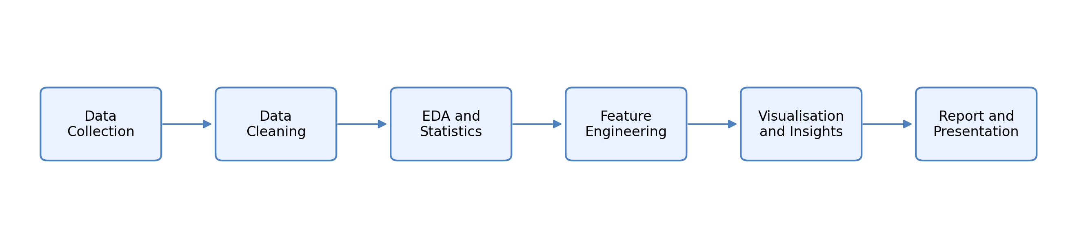
Data set schema used for analysis
Before performing any analysis, it is very important to understand the structure of data set that we are going to use in the project which contains several fields that describes a customer behavior, product, choice and transactions details
The first field which we can start with is a customer ID, which can act as a unique identify for each customer, which can help us to distinguish one customer from another and is useful for grouping and aggregating data. Second point, we can mention that like we can use a data set that includes demographic values such as age gender, which will help us to understand customer profiles and allowed to do comparison between different demographic groups. For example, we can take as spending pattern that can analyzed on the basis of age group or a gender category
We can also use the product related information which is captured through a feel like item, purchase, and category of an item, which will help us further to verify the customer preference and identify which product or are more popular. So now the payment comes like the payment amount should be in rupees or should be in dollars that represent how much a customer spend on a particle purchase, which will help us to verify or like to mark the important variables in the data set, which can relate directly to our revenue and a customer value.
Now the points come to a geographical location through which we can find the feel like through which we can identify the sales of a product at which location which product is high in sales or which product is not in sale. We can also identify areas for higher and lower pending.
Most important thing is for customer feedback which will reflect the review rating field by we can focus the same customer feedback to make the product more popular in that area which have high demand for it.
The act which we are going to use will also include a behavioral indicator such as subscription status, which will show whether a customer is a member of subscriber. This can also be useful when we can while comparing spending between subscribers and non-customers.
Field | Purpose in analysis
Customer ID | Unique customer Identifier
Age and gender | Customer demographic profile
Item purchased and category | Product preferences indicators
Purchased amount | Observed spend value for the record purchase
Location | State wise
Season | Time related seasonal Context
Review rating | Post purchase opinion indicator
Subscription status | Customer membership/subscription flag
Payment method | Preferred payment mode
Frequency of purchase | Declared buying
Previous purchase | Simple loyalty/history signal

Engineered features
We can create an original data site that can provide as useful for information. Additional features where we can create and make the analysis more meaningful.
So, the first feature which can we create is a purchase per year since the original data contains purchase frequency in the data format or data set, we can convert it into a numerical value which can later represent the number of purchases per year and which will make it easier to perform and calculates and make us very helpful to do the comparison between previous year and the current year.
And another feature we can add is estimate purchase interval days. So there is a point like we can do a variable approximate that can define the time that between the purchased based on the frequencies information that that measures and provide a useful indication of a customer buy history
We can also add some advance feature like estimate, annual spend or estimate customer total spent in three years. First of all, we will talk about estimate annual spent which is a feature by which we can calculate by multiplying the purchase amount with the number of purchases per year, this can give us the estimate value that how much a customer can have or can spend annual. Now we can come to the point for that estimate customer purchase a total spend in three years which will help us to represent the lifetime value of a customer by this weekend adjust the previous purchase behaviour and the subscription status to make more realistic like like how much a customer is valuable to us or how much customer is this care about our product.
Now we can mention some points or some features related to a segment like a customer segment and a value segment. In customer segment. We can divide the group of a customers based upon their spendings purchase history, which will help us to identify the high value customer or a loyal customer. In a value segment. We can estimate the total purchase history of a customer spends on a product or on our store, which will allow us to create a simple or easier version to interact a customer, and then we can compare it to a different value set.
Features | Reason for creation
Purchase per year | Convert text to purchase frequency into numerical annual count
Estimate purchase interval days | Approximate time, gaps between purchase from Cadence field
Estimate annual spend | Purchase amount * purchase per year
Estimate customer spend in three years | Three years customer value proxy adjust by previous purchase and subscription status
Customer segment | Rule base segment, combining o and purchase frequency
Value segment | Quartile based CLV group
Age group | Banding variables used for demographic comparison

Visual design plan
Visualization is also an imported rule in presenting a customer clearly or a product data. Clearly. In this project, we are going to use a different type of a charge that are based on a different type of dataset.
Like bar chart, which can be used for a comparison for a top product, location, payment methods segments, which will help us to understand the effectiveness of a product in a different group in a different age of peoples.
We would be using your pie chart as well to represent different category share since the number of categories as limited pie chart can work well and provide a quick overview of a data
Do some different charts, we can also use line charts, heat maps like in line charts, we can analyses the trends such as seasonal spending changes in spending based on purchase frequency like in heat map, we can compare two variables at the same time like in different categories and sessions, they can identify the pattern that may not be visible in a simple charts.
We can also use histograms that can also show distribution such as age or a customer lifetime value that can help us by understanding how values are separated whether they data is skewed.
Visual | Used for | Reason
Bar chart | Top items, locations, payment methods, and segment | Best for comparison across categories
Pie chart | Category share | Useful, because the number of categories is small
Line chart | Seasonal average spend an annual spent by frequency | Good for ordered category
Heat map | Category vs season average spend | Show two-dimensional pattern clearly

Design notes on limitations
It will be a very important to consider the limitations of a data set, key limitation, data set represent a snapshot of a customer behaviour rather than a detailed transaction history since exact time of transactions are not available certain features such as purchase intervals and customer life value are estimated rather than calculating them precisely.
So by making this distinction is very important in both lethal and academical way that ensures the analysis should remain honest does not create a false impression of accuracy
Even with these limitations, the analysis still provides useful insights. However, the results should be interpreted as a approximate indicator rather than exact value. For example, we cannot provide exact data of a product like every product. History cannot be registered and every transaction history cannot be resisted as some transactions are made physically and some are made online.

Final conclusion of a chapter 4 will be: -
Like this system design, only focus on clarity and transparency. Each step which will be using in the workflow is clearly defined and which will make it easy to understand how analysis is performed and the combine structured data engineered features and well-chosen visualization ensure that the results are meaningful and easy to understand.

Chapter 5 : System Implementation
So finally, we came to the part of system implementation where we going to implement and carry out the project in python using a notebook subscript, so the notebook was used for exploration and a quick check while the final script used to generate the clean dataset summary files and final figures in a reproduce way. The combination will be practical in the student project because it’s allow experimentation during analysis and consistency during submissions.
Development environment
- Language will be python 3
- Libraries : Pandas, numpy, matplotlib, python-docx, google colab
- Data format : CVS
- OUTPUTS : Cleaned CVS, summary table, report, presentation, and charts
Cleaning logic
So the data site will be filed for the structures, null values and duplicates. Then the checked will show zero missing value and zero duplicate rules. So now no rows will be deleted and there won’t be any other issues. Even text columns towards standardised by trimming, whitespace and column. Names were normalised. So this will be the step to avoid silent grouping errors while performing categorical analysis.
Descriptive statics
Metric | Value
Average purchase amount | 59.76
Median purchase amount | 60
Average reviewing status | 3.75/5
Average estimate annual spend | 1038.93
Average estimate 3 years, CLV proxy | 4835.36
Median Estimate 3CLV proxy | 2508.77

Product and category analysis
The first visual question was product publicity, so the top item bar chart shows that the bloues, pants and jewellers are tied at the high frequency which are followed by T-shirts, dresses and sweater. Below data sheet suggested that mix of real essentials and fashion accessories from a business point of view. These items would be a reasonable starting point for bundle recommendation or a category label promotion.
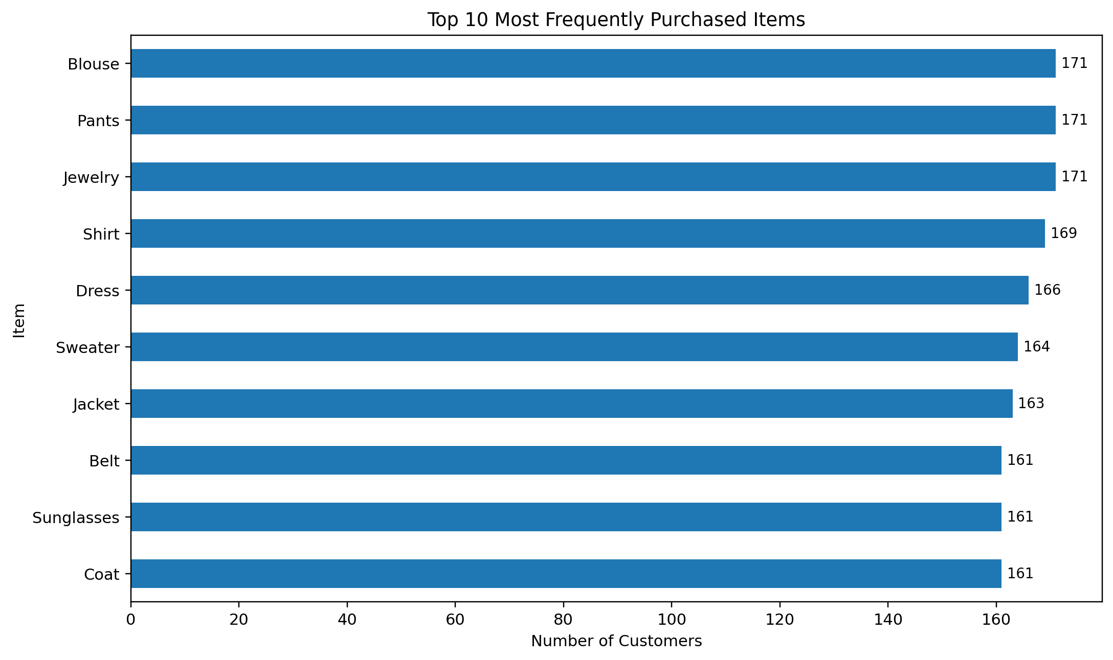
Now categories compositions gives a border view that the item frequency and cloth alone contributes 44.5% of the record purchase while accessories contribute 31.8% . Footwear and outwear together make up the remaining share. This means the business use using this port would like to treat clothing as an anchor category and use accessories for cross sale opportunity

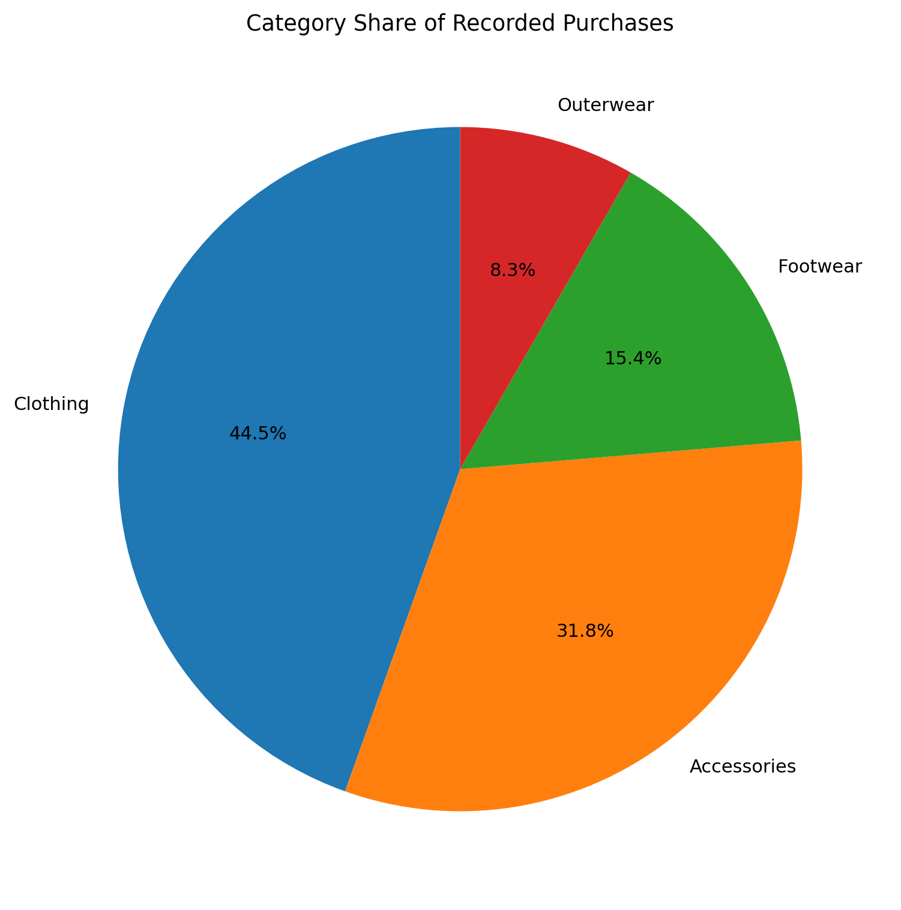
Seasonal analysis
The seasonal line chart shows a visible rise in average purchase amount during fall. Spring and summer remain close to each other while the winter site between the lowest summer point and the fall peak. The average session value at the approximately 5 8.74, summer 58.41, fall 61.56 and winter 60.36 so the difference is not extreme, but it is considered enough to suggest that the fall may deserve a stronger promotional attention or seasonal planning
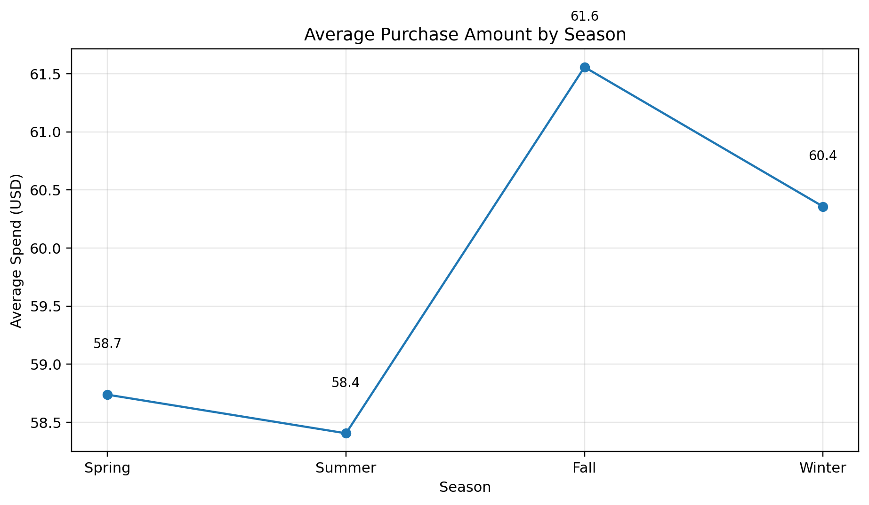Now it comes for the heat map defines the seasonal value by adding product, category, footwear, records, and the strongest average spend in the fall why clothes is considered strong in both spring and fall, but outer wear does not dominate strong as as expected, so the assumption is that the final season demand should be check against sexual data instead of being taken for the granted

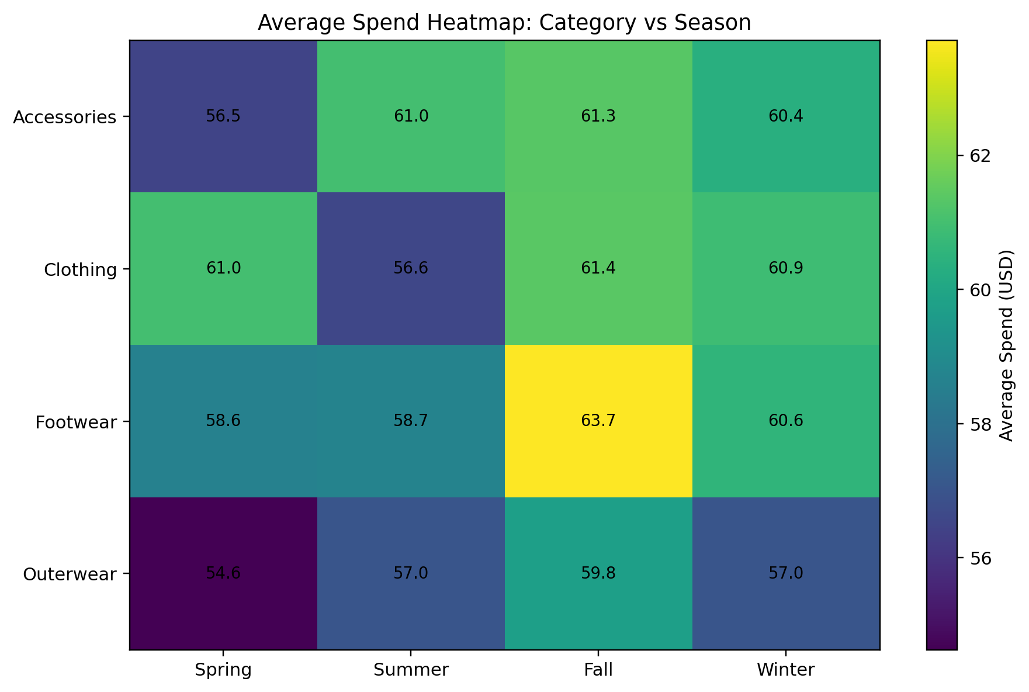
Demographic and geographic analysis
Show the age distribution feature across the adult range. Wood was very helpful for a customer behaviour studies because the analysis is not restricted to one narrow age band, like the group of 18–25 shows slight higher average spend then some other bands, but the different art very modest. So I would be suggesting that the age alone may not be the strongest driver in the data set as product and frequency variables appears more informative

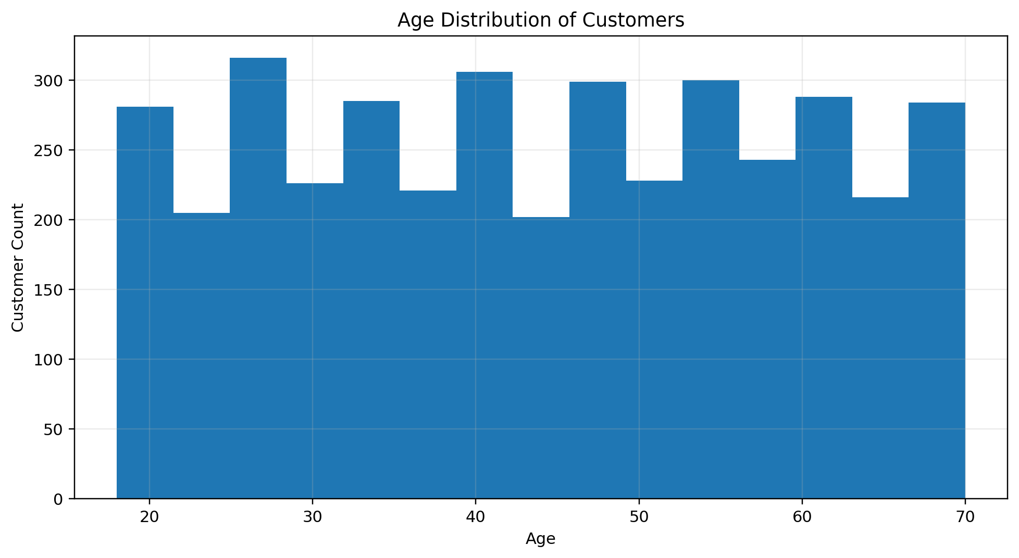
Now comes for the location, voice total, which shows that California Aloha, Nevada, Illinois and Montana are among the top state by total records per purchase value as geographical consideration. It will help in regional promotion planning through the report .
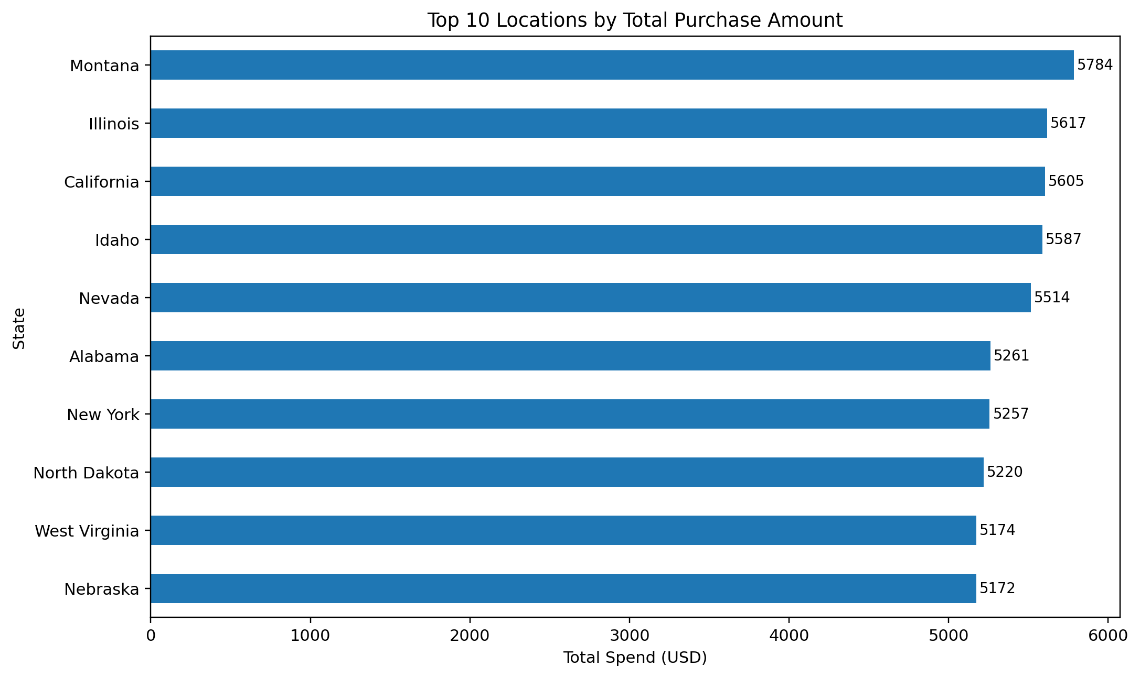
Payment behavior
Payment method shows that the small difference in the average purchase amount as card base methods are still highly ahead. So the Venmo is the lowest among the list method as a practical reading that the highest point is not limited to one payment mode, but card related options appears slightly better lid with a large purchase in the seat data set according to the Venmo or cash payment.
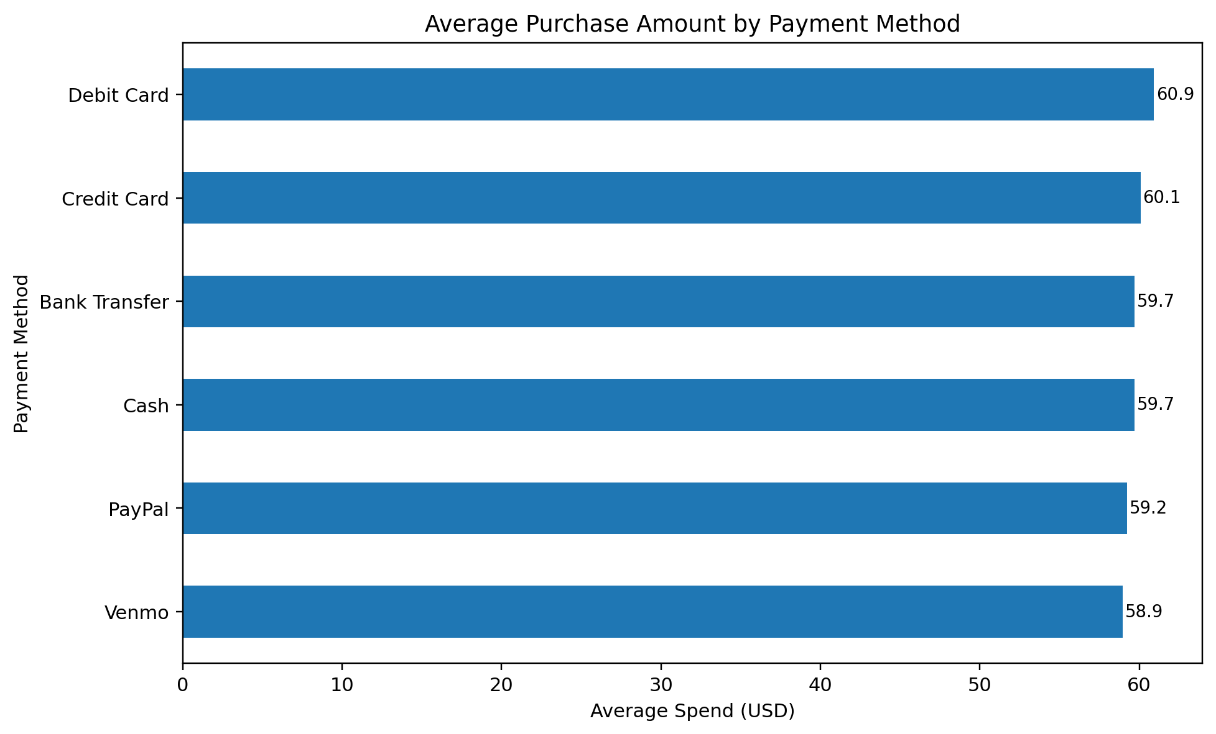
Feature, engineering and segmentation
Feature engineering was used to convert the data set from descriptive customer sheet into a more actionable business views like a frequency value. There was a part where weekly monthly or annually were mapped to numerical numbers count per year which was made possible to estimate, annual spend and build a simple CLV proxy. Now the segment approach was then used separate frequent highly customers from occasional high ticket, customers and low engagement groups.

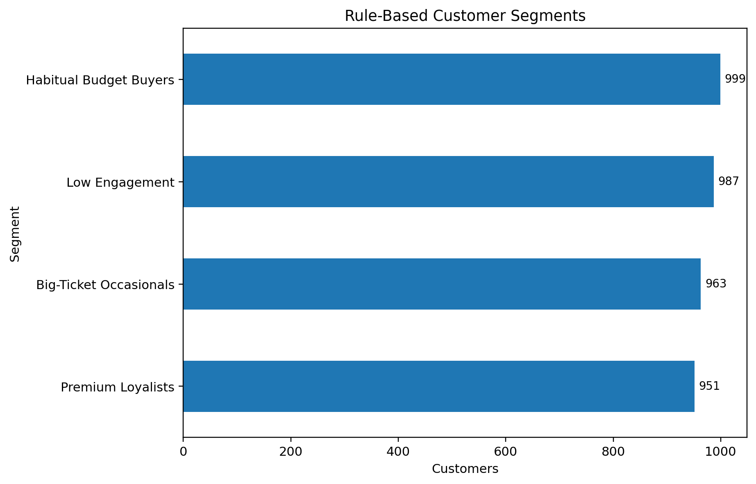
Accounts for the segment sides which are relatively balanced like habitual budget buyer 999, low engagement 987, big ticket, occasional 963, and premium loyalists 951 and the most useful manager lesson here is that the customer value is not only about a single purchase, but a lower ticket. Buyer was purchasing regular, which became more valuable over time than a customer who spends a lot only occasionally.

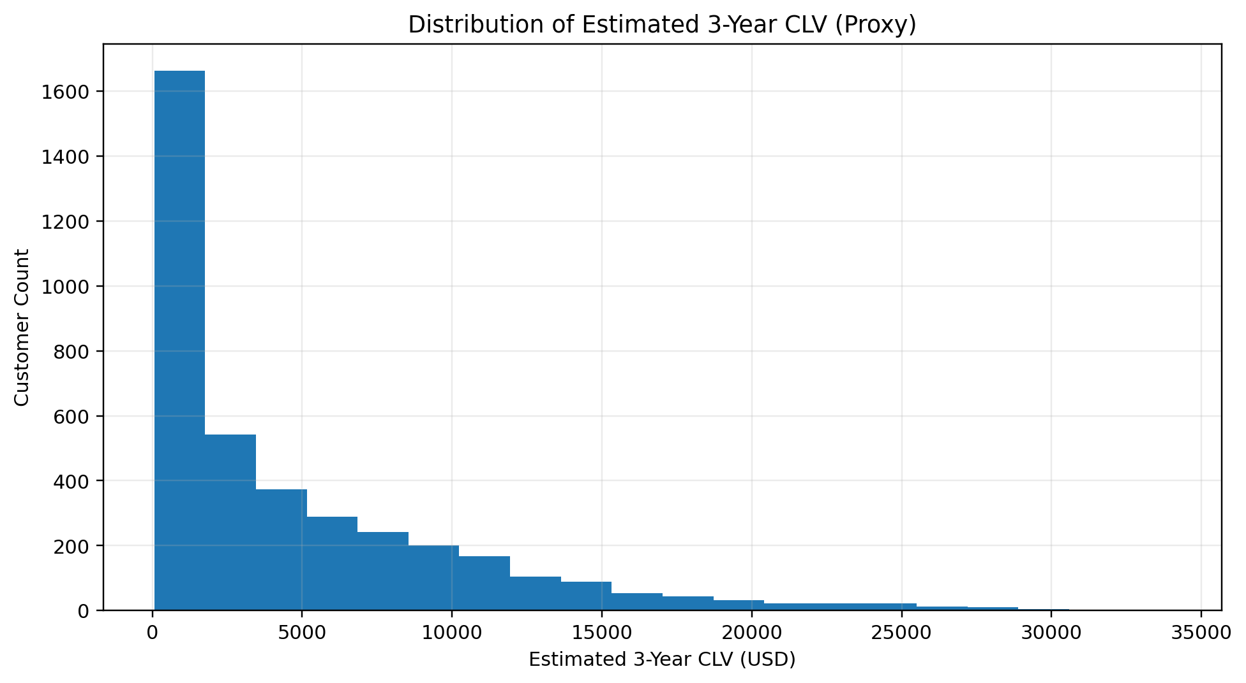
So the C LV proxy distribution which is a typical in customer value analysis in most customers cluster in the lower to middle range while a small group extended to a large IR estimated value. That SKEW suggest an opportunity for a tired marketing while premium services or loyalty rewards are focused on the upper tail instead of being offered uniform me to every customer.

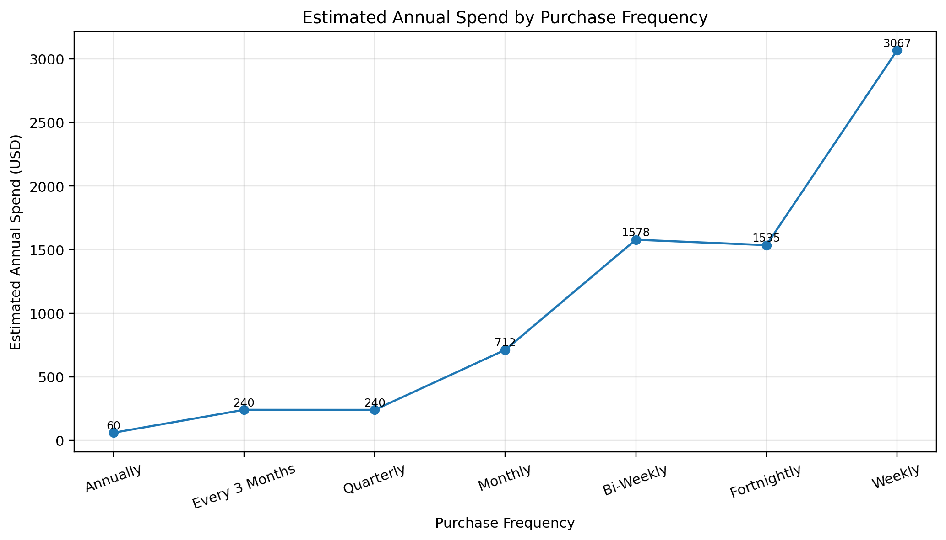
The upper blind chart makes one relationship very clear that annual spend rice sharply when buying frequently. Weekly end by weekly customer look specially important in the proxy analysis. Even when their average single purchase amount is not dramatically higher than the rest, this insights, support, loyal building and repeat purchase strategy.

Programs

Program 1: Load Dataset and Preview
import pandas as pd
file_path = "shopping_trends.csv"
df = pd.read_csv(file_path)
print("Dataset loaded successfully")
print(df.head())
print("Shape:", df.shape)
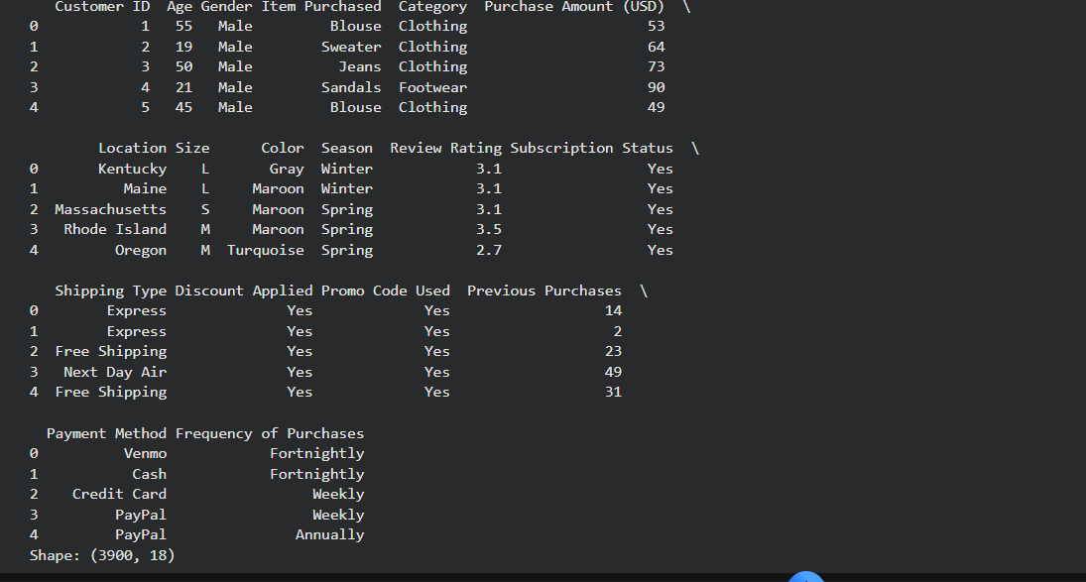

Program 2: Display Column Names
import pandas as pd
df = pd.read_csv("shopping_trends.csv")
print("Column names in dataset:")
for col in df.columns:
print(col)
print("Total columns:", len(df.columns))

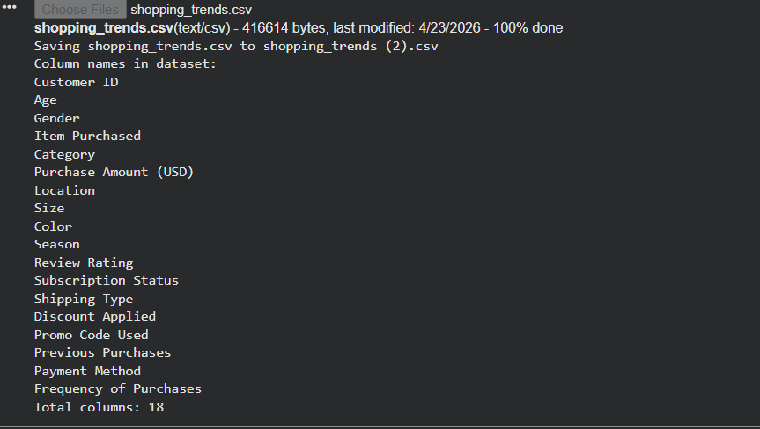

Program 3: Check Missing Values
import pandas as pd
df = pd.read_csv("shopping_trends.csv")
missing = df.isnull().sum()
print("Missing values per column:")
print(missing)
print("Total missing:", missing.sum())
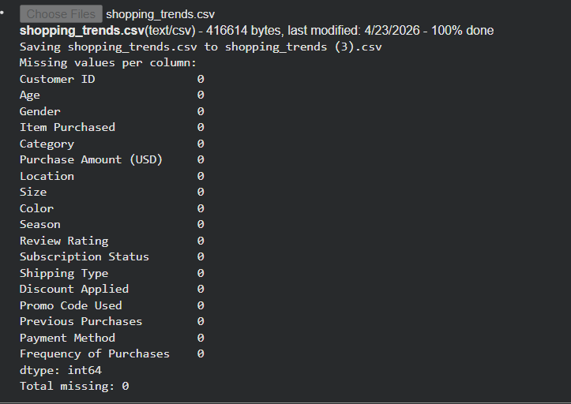

Program 4: Remove Duplicate Rows
import pandas as pd
df = pd.read_csv("shopping_trends.csv")
before = len(df)
df = df.drop_duplicates()
after = len(df)
print("Rows before:", before)
print("Rows after:", after)
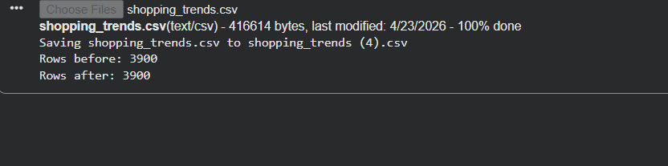

Program 5: Normalize Column Names
import pandas as pd
df = pd.read_csv("shopping_trends.csv")
df.columns = df.columns.str.strip().str.lower()
print("Normalized column names:")
print(df.columns)
print(df.head())
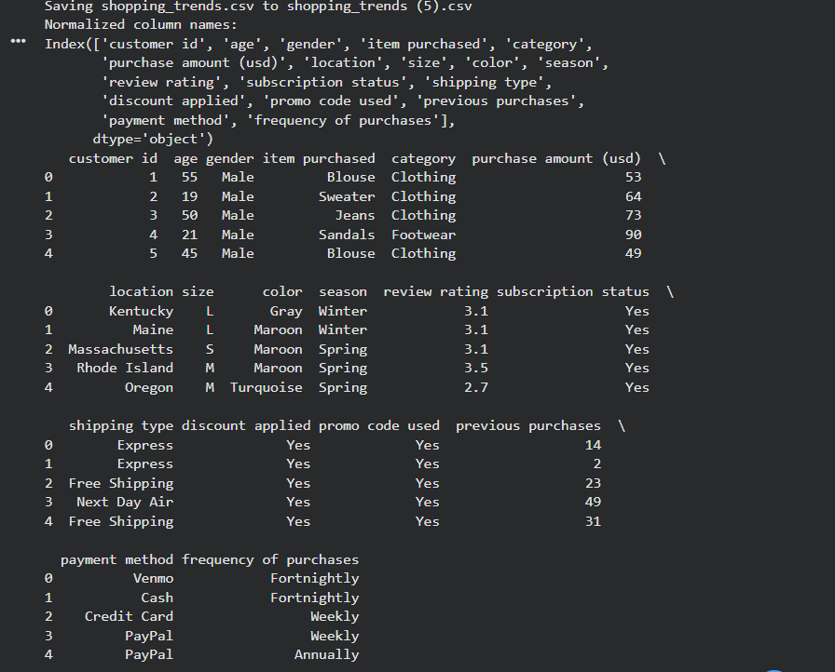

Program 6: Descriptive Statistics
import pandas as pd
df = pd.read_csv("shopping_trends.csv")
print("Descriptive statistics:")
print(df.describe())
mean_val = df['Purchase Amount (USD)'].mean()
print("Mean purchase amount:", mean_val)
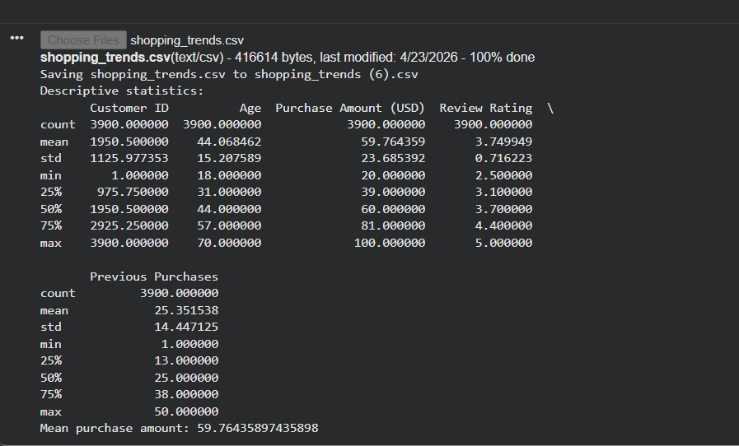

Program 7: Top Products Analysis
import pandas as pd
df = pd.read_csv("shopping_trends.csv")
top_items = df['Item Purchased'].value_counts().head(5)
print("Top 5 products:")
print(top_items)
for item, count in top_items.items():
print(item, "->", count)
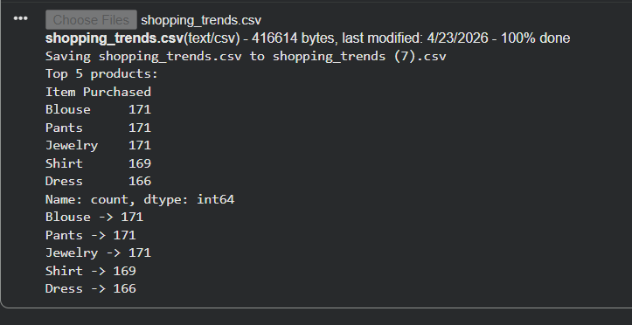

Program 8: Category Distribution
import pandas as pd
df = pd.read_csv("shopping_trends.csv")
category_counts = df['Category'].value_counts()
print("Category distribution:")
print(category_counts)
print("Total categories:", len(category_counts))
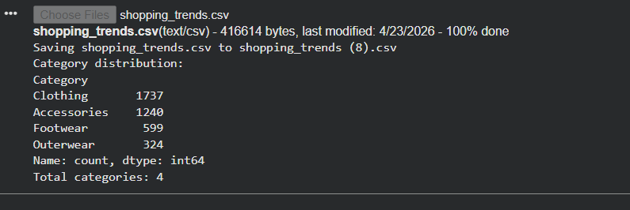

Program 9: Gender-wise Spending
import pandas as pd
df = pd.read_csv("shopping_trends.csv")
gender_spend = df.groupby('Gender')['Purchase Amount (USD)'].mean()
print("Average spending by gender:")
print(gender_spend)
print("Analysis complete")
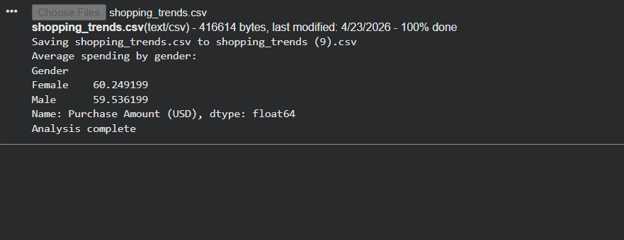

Program 10: Seasonal Spending Analysis
import pandas as pd
df = pd.read_csv("shopping_trends.csv")
season_avg = df.groupby('Season')['Purchase Amount (USD)'].mean()
print("Average spend by season:")
print(season_avg)
print("Highest season:", season_avg.idxmax())
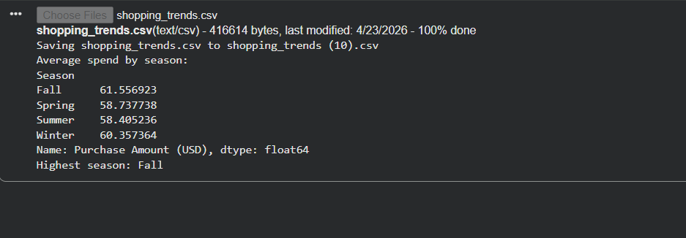

Program 11: Location-wise Sales
import pandas as pd
df = pd.read_csv("shopping_trends.csv")
location_sales = df.groupby('Location')['Purchase Amount (USD)'].sum()
print("Top locations by sales:")
print(location_sales.sort_values(ascending=False).head())
print("Done")
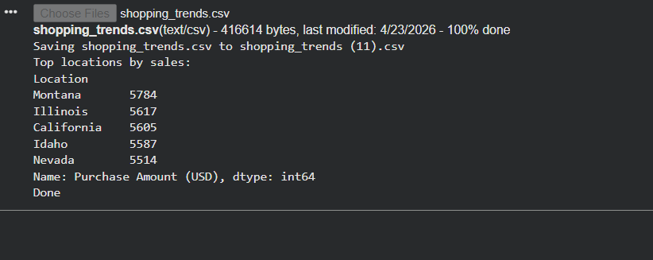

Program 12: Payment Method Analysis
import pandas as pd
df = pd.read_csv("shopping_trends.csv")
payment_avg = df.groupby('Payment Method')['Purchase Amount (USD)'].mean()
print("Payment method analysis:")
print(payment_avg)
print("Best method:", payment_avg.idxmax())
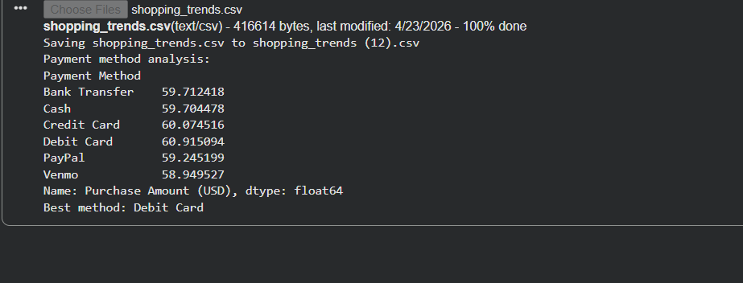

Program 13: Frequency Mapping
import pandas as pd
df = pd.read_csv("shopping_trends.csv")
freq_map = {'Weekly': 52, 'Monthly': 12, 'Quarterly': 4}
df['Freq_Num'] = df['Frequency of Purchases'].map(freq_map)
print(df[['Frequency of Purchases', 'Freq_Num']].head())
print("Mapping completed")
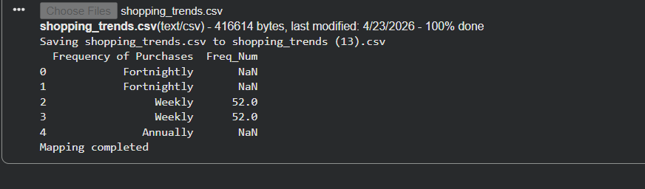

Program 14: Annual Spend Calculation
import pandas as pd
df = pd.read_csv("shopping_trends.csv")
freq_map = {'Weekly': 52, 'Monthly': 12}
df['Freq_Num'] = df['Frequency of Purchases'].map(freq_map)
df['Annual Spend'] = df['Purchase Amount (USD)'] * df['Freq_Num']
print(df[['Annual Spend']].head())
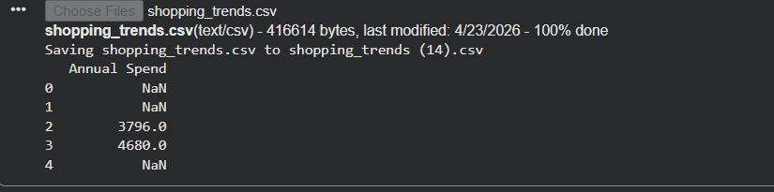

Program 15: Customer Segmentation
import pandas as pd
df = pd.read_csv("shopping_trends.csv")
def segment(x):
if x > 2000:
return "High"
elif x > 1000:
return "Medium"
else:
return "Low"
df['Segment'] = df['Purchase Amount (USD)'].apply(segment)
print(df['Segment'].value_counts())
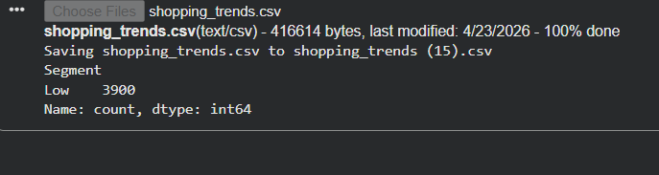

Program 16: Age Group Creation
import pandas as pd
df = pd.read_csv("shopping_trends.csv")
df['Age Group'] = pd.cut(df['Age'],
bins=[18,25,35,50,60],
labels=['18-25','26-35','36-50','50+'])
print(df[['Age','Age Group']].head())
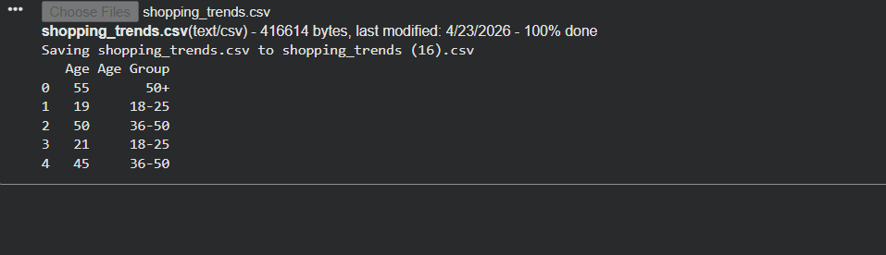

Program 17: Bar Chart for Top Items
import pandas as pd
import matplotlib.pyplot as plt
df = pd.read_csv("shopping_trends.csv")
top = df['Item Purchased'].value_counts().head(5)
top.plot(kind='bar')
plt.title("Top Items")
plt.show()
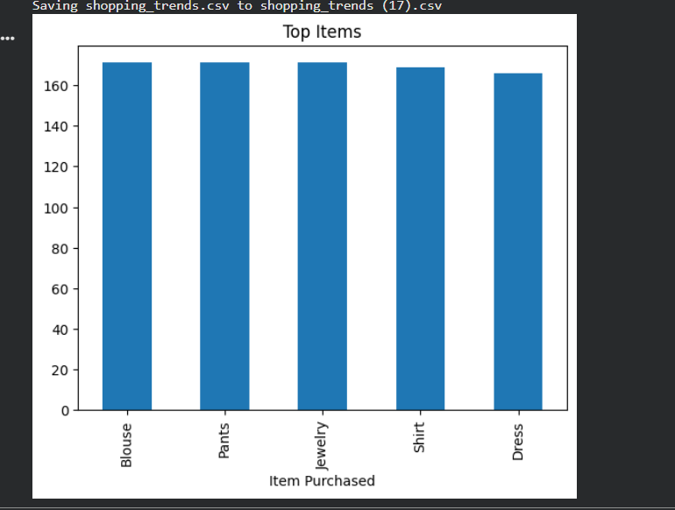

Program 18: Pie Chart for Category Share
import pandas as pd
import matplotlib.pyplot as plt
df = pd.read_csv("shopping_trends.csv")
df['Category'].value_counts().plot(kind='pie', autopct='%1.1f%%')
plt.title("Category Share")
plt.show()
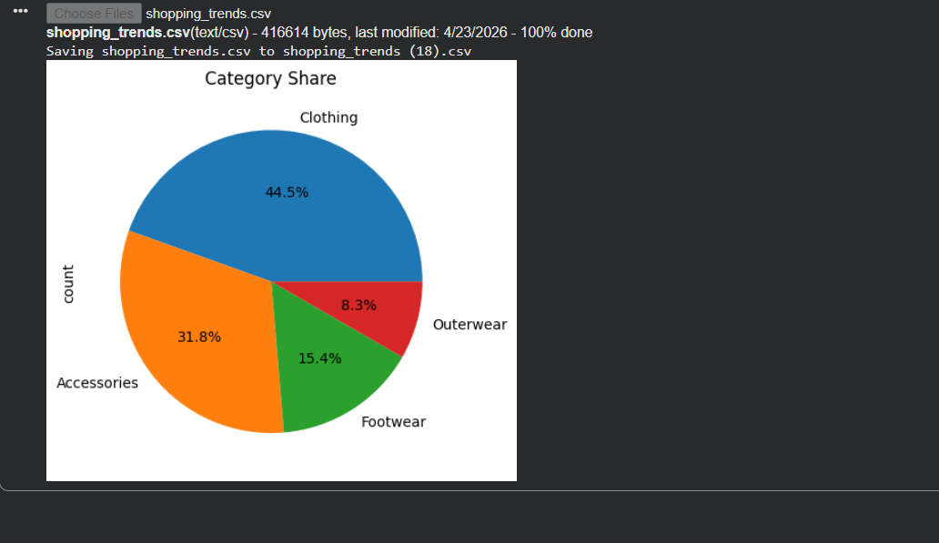

Program 19: Histogram for Age Distribution
import pandas as pd
import matplotlib.pyplot as plt
df = pd.read_csv("shopping_trends.csv")
df['Age'].hist()
plt.title("Age Distribution")
plt.show()
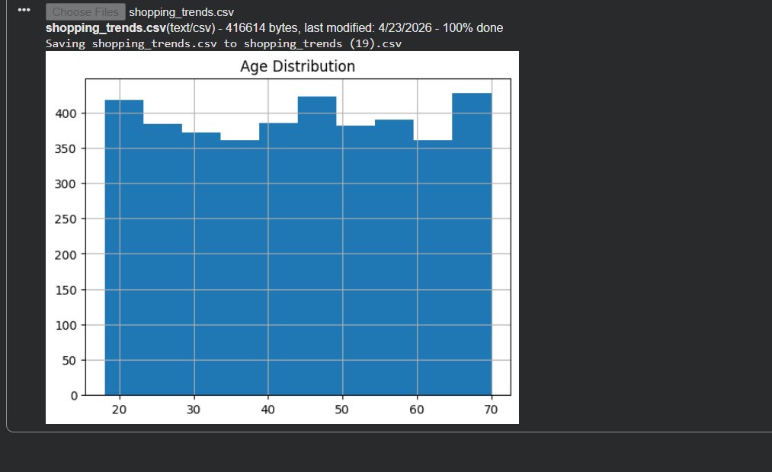

Program 20: Export Cleaned Dataset
import pandas as pd
df = pd.read_csv("shopping_trends.csv")
df = df.drop_duplicates()
df.to_csv("cleaned_data.csv", index=False)
print("Cleaned file exported successfully")
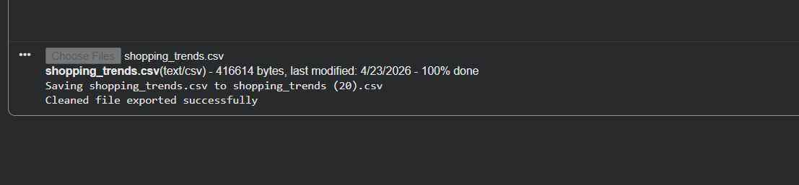

Chapter 6: Testing
So this project is like focused on data analysis rather than any building software application. The concept of testing is slightly different air as of software testing. So the testing would involve checking systems functionality, user interactions, and performance under conditions. However, in this condition or a case, the system is an analytical workflow itself.

So the main focus of testing here is to ensure that the data is accurate transformation and are applied correctly and the output such as summarise, start and local consent are logical. To answer the structure, validation approach, each step in analysis pipeline is checked carefully to make sure that it behaves as expected. This includes a verify the data set, validating transformations, and confirm that outer are generate correctly.
Test ID | Test | Result | Status
T01 | check Data set load | CSV open without schema failure | Passed
T02 | check missing value | Null Count is equal zero | Passed
T03 | check, duplicate rows | Duplicate count equals zero | Passed
T04 | Validate frequency mapping | All frequency labels maps to numeric value | Passed
T05 | Validate engineer, spend fields | Estimate annual spent is numeric and positive | Passed
T06 | Validate CLV proxy | Estimate CLV is numeric and non-Null | Passed
T07 | Check chart, export | All figures saved successfully and readable | Passed
T08 | Check documentation Output | Notebook, report and presentation generated | Passed

Data validation and testing approach
Testing passes in this project is organised. Is it checklist of validation steps? Each step focus on a specific part of analysis and ensures that no major issue is overlooked.

The first point involves checking whether the data sides loads correctly. The CVS file should open without any scheme. My shoes meaning that all columns are properly recognise and No data is lost during loading. This is important because an error at this would affect all the analysis.

And the next step is to check for a missing value in in real world data set as a missing data is quite common. I need to be handled cave carefully. However, in this case, the data said does not contain any null value, which simplify the processing stage
Another important validation step is to check for the duplicate rules. As duplicate records can start results, especially when calculating totals or average in this data set, no duplicates were found, which again helps in maintaining accuracy.
After validating the basic structure of data, our next step is to check transformation logic, for example, the purchase frequency field is original in textual format, so this needs to be converted into a numeric value for further analysis.
Another practical expect of testing involving checking whether all visual output are generated properly. This includes verifying the charts that are saved correctly and can be viewed without any issue if charge fails to export, it can affect the completeness of a report.

Finally, the overall output of the projects are validated. This includes confirming that the notebook written report and presentation slides. A successfully created and contains the expected content.

Data validation discussion
So this part is going to be very interesting as an aspect of this project that the data sites required were very clean and in the real world, success scenarios, data is often messy and contain missing values or errors. But in this case, data set appears to be well prepared and structured.

This turn out to be very helpful from an academic perspective. Since less time was needed for cleaning and more attention could be taken to given understanding the data performing analysis and creating meaningful features.

However, it is not important to take clean data for granted even when a data set looks perfect, it’s need to be checked carefully like any incorrect transformation can lead to a misleading result. For example, text base fields are reviewed to ensure values. Similarly, transformation steps are verified to confirm that the calculation are applied correctly. This will help us to avoid errors that may not be immediately visible, but can be effective in the final outcome.

Analytical sanity check
In additional to basic validation, the project also include several analytical sanity check as these checks are used to ensure that the result make logic science and are not just technical correct.

One importance steps involve delivering seasonal values since seasonal is are not natural numeric. They are arranged in logical order, spring summer fall and winter before creating visualisation. This ensures that the chart follow a meaningful sequence rather than appearing random

Key to check purchase frequency mapping as frequency is converted from text to numeric form. The mapping is reviewed carefully. Any mistake in the step could lead to a incorrect calculation of an annual spending or a customer value in the project. Also take care to certain metrics for example, lifetime value and purchase intervals are clearly described as estimated. This is because the data said does not contain exact timestamp, making precise calculation, impossible.

Limitations found during testing
During the testing process, a few limitations in data set were identified as one of the most noticeable observation was to relate variables like discount applied and promo code used.
In the data set, both columns contain exactly the same value for all Rose. This means that they do not provide dependent information and cannot be used to drive separately..
Instead of focusing on interpretation from these variables, the project acknowledged his limitations and avoid over analysing them rather than focusing on week variables. The analysis gives more importance to strong dimensions such as product categories, seasonal trends, purchase, frequency, and customer segments. These areas provide more meaningful and reliable information.

Conclusion of chapter 6
In conclusion, testing and validation in this project, focus on ensuring data, accuracy, correct transformations, and accurate or reliable outputs. Even though the data set is relatively clean, proper check or performed at every stage to maintain and avoid arrows.

So the use of validation step, sanity, check, and careful review of outputs help in building confidence in the result.

Chapter 7: Results & Discussion
Basically, in this chapter, we are going to combine the visuals and the descriptive finding into the business oriented interpretation. So our goal will be not just say that which shows but he will try to explain what the pattern matters.

Main findings
- We saw that clothes is the dominant category, contributing nearly half of the database value. Accessories are the second major contribution and can support cross selling strategies.
- Which falls under the high average purchase amount that through which we can suggest us seasonal opportunity for better time, inventory, and campaigns.
- The top products are spread across both real and accessories, so demand is not concentrated in only one narrow sub category.
- It comes that the payment method differences are small but debit card credit card uses show slightly higher average speed.
- We also saw that frequent buyers emerged such as strategical important. Even a single order value are moderated. This is very visible annual and CLV proxy introduce.
- Customer value is skyrocketed and even a high value exist which supports retention effort, efforts rather than one size fits all engagement
Segment profile summary
Segment | Count | Interpretation
Premium loyalist | 951 | High spent and high frequency results in ideal for Loyalty rewards and early access offers
Big ticket, occasionals | 963 | Strong basket value, but load lower frequency results in repeated purchase nudges
Habitual budget buyers | 999 | Moderated basket value, but frequent suitable for bundling and subscription Campaigns
Low engagement | 987 | Lower spent and lower frequency suitable for reactivation and target discount test

Dashboard summary
For the presentation purpose, the major visuals were also contents into a similar dashboard. The kind of layout which will be useful when the audience want a quick overview before reading detailed chapter wise explanation. So the below chart contain a combine chart of a DeBoo which will represent the upper summary of upper project.
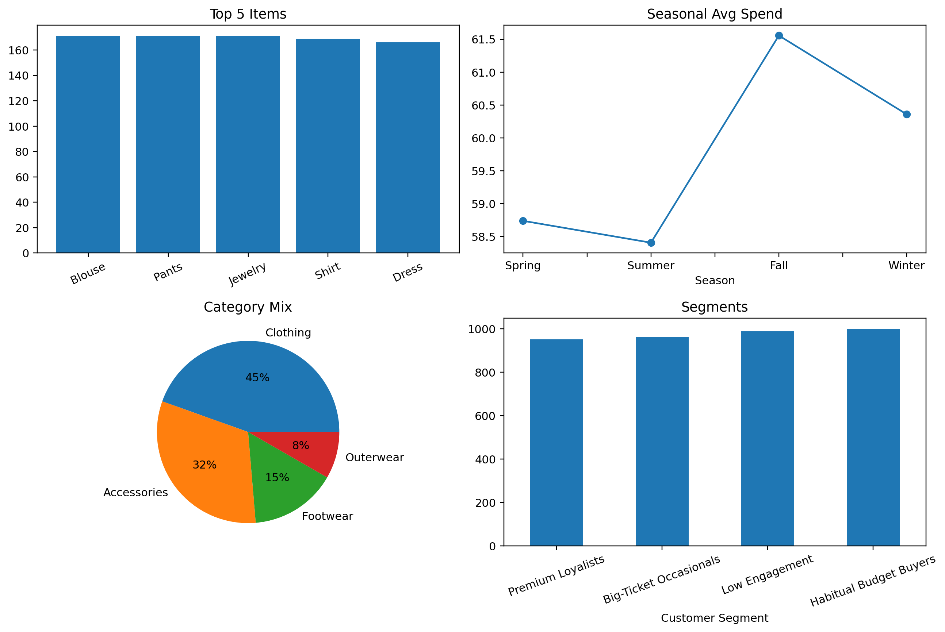
Discussion of reliability
So the results which are consistent inside the data set can be read in the right context. This is an educational, customer label shopping tense data set, but not as a live business warehouse.

Therefore, the pattern which we are demonstrating is for analytical reasoning, chart, designing, and business, interpretation, but we should not treated it as a direct evidence about the border retail market without additional external validation.

Chapter 8: Conclusion & Future Scope
This project was carried out with the aim of understanding customer purchase behaviour using exploratory data analysis and visual techniques. While starting this project, the idea was to build overly complex to understand how much value can be expected from dataset using basic but structure analysis, so the process became clear that even a simple data set when explode properly can reveal a meaningful insights.
The analysis begin with a public shopping data such which was first examine for the structured and quality. Then the basic check was done such as identify missing values, duplicate records and some techniques also was perform to ensure that the data set was very reliable. Since the data says was already fair, clean, more focus could be given to understand the pattern rather than spending excessive time on cleaning it.
Once the data was ready, we descriptive analysis for carried out to get a journal standing of customers behaviour. There was a different expect such as product category, seasonal trend, customer demographics and payment matters were explore. During this face, certain categories such as clothing and accessories dominated the data set. Which indicated that customer interest was not evenly, distributed, and some products typically attract more customer.

One thing which was very interesting, which I found was that a purchase frequency play a major role in overall customer value. Customer who spends less in a single transaction, but by frequently can actually contribute more over time compare to someone who makes occasional high value purchase. This is because more visible. After analysing the statement, annual spend and CLV proxy.
In this project like we does not mention a very high advanced level machine learning techniques. Initially it might seems that without a complex models, the insights may be limited. However, this project clearly shows that a well structured data analysis can still provide strong and useful conclusion.
We can give an another takeaway from this project that the important of asking the right questions instead of directly, creating charts, the analysis was guided by the specific question such as which category performance better in house, seasonality affects pending, and what kind of customer contributed more values. So the approach made the analysis more meaningful and easier to explain.

Future scope
Well, this project achieved its main objective. There was several ways in which this project can be extended. Further if additional data to set are visible analysis made more detailed and closer to real world application of the most important improvement would be inclusion of a real transaction dates. The data which we use in this current project does not contain any time related analysis, which is a very limited because there are no exact time for each purchase. If it would be visible or available with us, it would be possible to perform a Renaissance analysis, identify month or a week trends and calculate customer lifetime value more, so it would make significantly improve the quality of insights.
Future idea | Expected value
Add real transaction dates | Would enable exact recency, Monthly trend analysis and better CLV modelling
Build an interactive dashboard | Would make the Result, easier to filter by category, state or segments
Use clustering algorithms | Could replace ruled base segmentation with the data driven customer groups
Add recommendation, logic | Frequent co-purchase patterns could support, building or personalise suggestions
Deploy the workflow | The notebook/script can be extended it to a small Web dashboard or BI pipeline

Chapter 9: References
Hariharan, H. (2025). Customer Purchase Behavior (Version 1) [Data set]. Mendeley Data.
https://doi.org/10.17632/xv99b2mtfk.1
Pandas Development Team. (2025). pandas’ documentation. https://pandas.pydata.org/docs/
NumPy Developers. (2025). NumPy user guide. https://numpy.org/doc/
Matplotlib Development Team. (2025). Matplotlib documentation. https://matplotlib.org/stable/
Python Software Foundation. (2025). Python 3 documentation. https://docs.python.org/3/
Project. https://colab.research.google.com/
McKinney, W. (2022). Python for Data Analysis (3rd ed.). O’Reilly Media.
Tukey, J. W. (1977). Exploratory Data Analysis. Addison-Wesley.
Knaflic, C. N. (2015). Storytelling with Data. Wiley.
Bruce, P., Bruce, A., & Gedeck, P. (2020). Practical Statistics for Data Scientists (2nd ed.). O’Reilly
Media.
Provost, F., & Fawcett, T. (2013). Data Science for Business. O’Reilly Media.
Wickham, H., & Grolemund, G. (2017). R for Data Science. O’Reilly Media.
Kotler, P., & Keller, K. L. (2016). Marketing Management (15th ed.). Pearson.
Farris, P. W., Bendle, N. T., Pfeifer, P. E., & Reibstein, D. J. (2010). Marketing Metrics (2nd ed.).
Pearson.
Power BI Documentation. (2025). Microsoft Learn. https://learn.microsoft.com/power-bi/
Tableau Documentation. (2025). Tableau Help. https://help.tableau.com/
Hunter, J. D. (2007). Matplotlib: A 2D graphics environment. Computing in Science & Engineering, 9(3),
90–95.
Harris, C. R., et al. (2020). Array programming with NumPy. Nature, 585, 357–362.
Van Rossum, G., & Drake, F. L. (2009). Python 3 Reference Manual. CreateSpace.
Open AI for Research.

Chapter 10: Appendices
Appendix A: Project Folder Contents
data/shopping_trends.csv - raw dataset
data/shopping_trends_cleaned.csv - cleaned and feature-enhanced dataset
notebooks/customer_purchase_behavior_analysis.ipynb - analysis notebook
figures/ - charts used in the report and presentation
src/analyze_customer_behavior.py - reproducible script
slides/ - final presentation
docs/ - final report files

Appendix B: Extended Visual Evidence
The following pages include additional charts that support the chapter-wise interpretation. These pages are useful during viva voce because they show the evidence behind the written discussion.

Observation: The customer base is spread across a broad age range, which means the project is not centered around only one narrow demographic band.

Observation: The payment-method differences are visible but not extreme. This supports a balanced interpretation instead of overstating the effect.

Appendix C : Location and Value Views

Appendix Figure E.1 Top 10 locations by total purchase amount
Observation: Some states appear at the top in cumulative spend, but these should be read as dataset-level indicators rather than universal market truths.

Observation: The CLV proxy is right-skewed, which means a smaller set of customers contributes a disproportionately large share of projected value.
Appendix D : Frequency and Segment Support

Observation: Frequency amplifies value quickly. Even when individual purchase amounts are moderate, repeated buying lifts the annualized value sharply.
Observation: The four segments are fairly balanced in count, which makes the segmentation useful for explaining differentiated business actions.

